To: Members of the Statutory Accounting Principles (E) Working Group
From: IMR Ad Hoc Group
Re: Recommendation for Removal of Hypothetical IMR
Date: SAPWG Draft – 3-6-2025

Background
Accounting guidance for IMR in reinsurance transactions has existed since the inception of IMR as a statutory accounting concept in the early 1990s and is contained in the Annual Statement Instructions for Life, Accident and Health/Fraternal insurers. These instructions identify three potential types of IMR to be accounted for in a reinsurance transaction: Existing IMR, Newly-Created IMR, and Hypothetical IMR. Relevant excerpts of the instructions are included below (notes and emphasis added):
The amount of the gain (loss) that is interest-related and its IMR amortization should be determined using the following three step procedure for the portion of the block sold, transferred or reinsured.

- Identify the IMR balance and future amortization arising from the past (Existing) and present (Newly-Created) dispositions of the assets associated with the block of liabilities.

- Identify the IMR balance and future amortization that would result if the remaining assets associated with the block of liabilities were to be sold. (Hypothetical)

- Define the interest-related gain (loss), net of taxes, to be the negative of the sum of the IMR balances determined in steps 1 and 2. The future amortization of the gain (loss) is the negative of the sum of the amortization determined in steps 1 and 2.

The associated assets are the assets allocable to the reinsured block of business for the purposes of investment income allocation. If the ceding company has not been tracking the investment income of the block, it should retrospectively identify the assets using procedures consistent with its usual investment income allocation procedures. The associated assets are not necessarily the same as the assets transferred as part of the transaction.

The instructions then walk through an example illustrating the components, in which a portion of the block of assets allocable to the block are not transferred, but a ceding of IMR is to be recorded as if it had:

Assets with a book/adjusted carrying value of $20 million and a market value of $21 million from the original block of assets allocable to the line of business remain in the company’s portfolio after the transaction is completed. If these assets were to be sold at the time of the reinsurance transaction, they would generate a before-tax capital gain of $1 million and an after-tax capital gain of $.66 million that would be amortized through the IMR as follows:

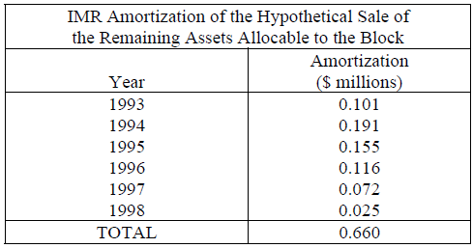

Note that if these assets are actually sold at some point subsequent to the reinsurance transaction, the sale price would be different from the hypothetical price to the extent that interest rates had changed subsequent to the reinsurance transaction.
[…..]
In order to calculate the IMR amortization associated with the reinsurance of the liability, it is first necessary to determine the IMR amortization from past, present and hypothetical asset sales of assets allocable to the block of business.

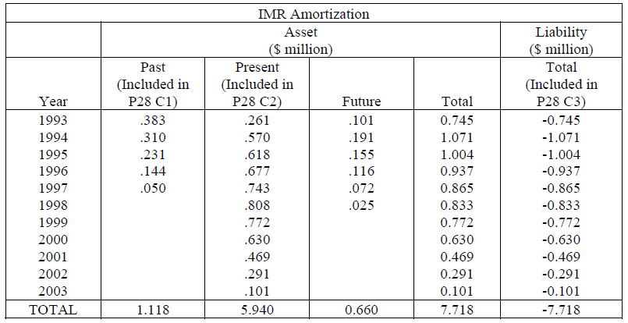

The IMR amortization associated with the liability is displayed in the last column of the above table and it is simply the complement of the IMR amortization associated with the past, present and hypothetical future assets sales. The liability amortization should be entered in Column 3 of the IMR Amortization Worksheet of the Annual Statement of the ceding company. By definition the size of the interest-rate related gain is the total transferred to the IMR, -$7.718 million, which should be included on Line 3 of the IMR worksheet of the ceding company as well as on the Aggregate Write-ins for Deductions on the Summary of Operations and Analysis of Operations by Lines of Business.

While the instructions do not discuss the rationale for the concept of hypothetical IMR, the intent clearly was for there to be a process to determine allocable assets for the block and to recognize the cession of the IMR that would have been generated had those assets been sold at the time of the transaction, even though the IMR being ceded does not yet exist on the balance sheet.

Recommendation of the IMR Ad Hoc Group

Through the early discussions of the IMR Ad Hoc Group, several observations became clear:

- The concept of Hypothetical IMR was not well understood by insurers, regulators, or NAIC Staff.
- Even very knowledgeable statutory accounting and reinsurance experts either did not know that the concept existed or could not articulate its purpose or how it would arise.
- As a result, Hypothetical IMR is rarely being recognized in practice.

After these observations were recognized, the IMR Ad Hoc Group undertook a significant effort to substantiate the purpose of Hypothetical IMR in order to determine its necessity, document the rationale for it and if the concept is decided to be retained, improve the instructions for how it is determined in order to promote more uniform adoption. The successful outcome of this effort is documented in the remainder of this paper.

Recommendation: Although the IMR Ad Hoc Group was able to establish that Hypothetical IMR has valid theoretical purpose, it is the recommendation of the Group that the establishment of Hypothetical IMR not be retained as a practice.

Analysis

Illustration

In order to establish the theoretical basis for Hypothetical IMR, the IMR Ad Hoc Group created an example to illustrate how the allocation of assets used as consideration in a reinsurance transaction can result in different impacts to surplus without the establishment of Hypothetical IMR. The spreadsheet example is attached in Appendix A. Excerpts are included here to illustrate the concept.

First, an assumption was made for purposes of the illustration that a cedant and reinsurer would negotiate an agreed market value of net consideration necessary for each party to enter into the transaction. The parties would be agnostic to which assets are used as consideration or breakdown of what is deemed to represent premium or ceding commission. To illustrate the concept, the extreme example of a 100% coinsurance transaction of all of a cedant’s policyholder obligations was used. In one case, the bonds supporting the liabilities are transferred as consideration for the reinsurance, in the other case, cash that the cedant has on hand is used as consideration. As the market value of the bonds differs from book value, an adjustment to the ceding commission is assumed to result in the same market value of consideration.

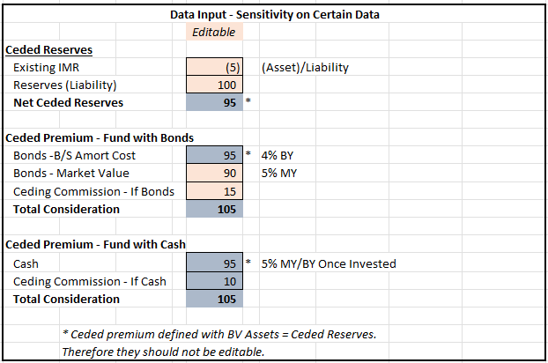

Next, the balance sheet result of each version of the transaction was illustrated. Without recording a Hypothetical IMR adjustment, the results are as follows:

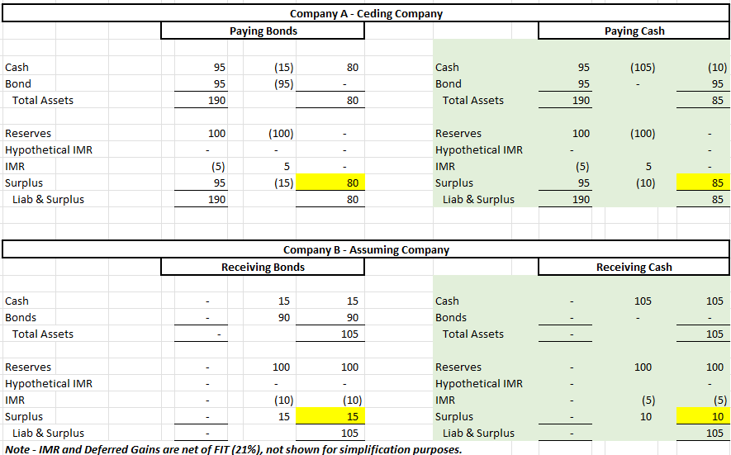

As can be seen in this example, both the ceding company and the assuming company have different ending surplus results from the transaction, despite the transactions being economically equivalent.

The same transaction was then illustrated, by making an adjustment for Hypothetical IMR:
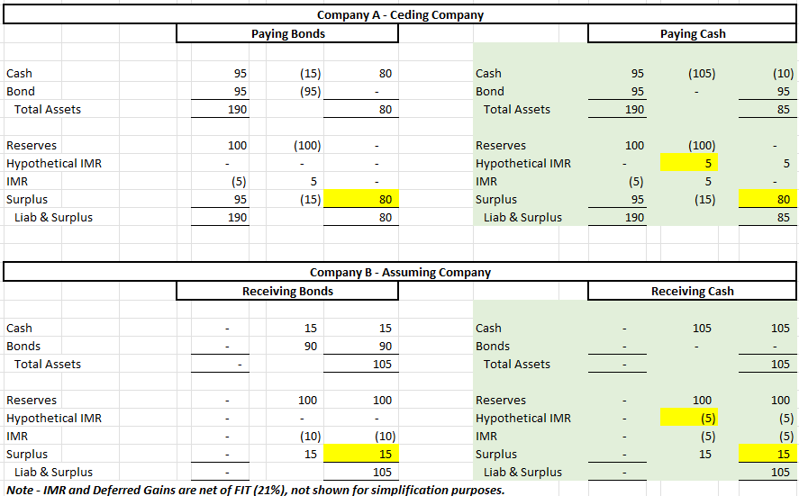

As can be seen in the revised example, Hypothetical IMR is recorded at both the ceding company and the assuming company, which is equal to the built-in unrealized loss on the bonds that had previously supported the block but no longer do since cash was substituted as consideration to the reinsurer. By recording this adjustment, the surplus outcomes of the transactions are equivalent without regard to which assets are used as consideration. Note that, which cash vs bonds was used in the example for simplicity of illustration, the same concept would hold true even if bonds were used as consideration, but different bonds than had previously backed the liabilities.

Qualitative Discussion

Next, the IMR Ad Hoc Group set out to define Hypothetical IMR to explain in qualitative terms the dynamics illustrated in the above example. Below is the definition and key points of justification for Hypothetical IMR as a theoretical concept:

Hypothetical IMR is a theoretical accounting mechanism used in the context of reinsurance transactions to maintain the alignment between insurance liabilities and the supporting assets when the actual (or a portion of the) fixed income assets backing the reserves are not transferred as part of the reinsurance consideration. This mechanism reflects the "built-in IMR" that would have been ceded had the bonds supporting the reserves been transferred. It ensures that the accounting effect of the transaction is neutral to the assets allocated, by recognizing the IMR that would have been generated if the actual bonds had been transferred and then amortizing this IMR over time.

Key Points in Justifying Hypothetical IMR

- The rationale for holding fixed income assets at amortized cost is their alignment with the reserve basis.
- The essence of IMR is to recognize the connection between assets and reserves, both maintained on an amortized cost basis.
- When the connection between assets and reserves is broken (i.e., the allocated assets are not transferred with the liabilities), this continuity of measurement can be disrupted and result in non-economic accounting impacts.
- Of particular concern are situations where there is an ability to game this disconnect to achieve a favorable accounting result that is not in line with the economics of the transaction. For example, negotiating reinsurance transactions to pay cash (at market value) instead of transferring bonds at market value, which could otherwise distort the economic reality of the transaction.
- Hypothetical IMR is an accounting mechanism to prevent any non-economic accounting impact that is theoretically possible.

After establishing the theoretical basis for the concept of Hypothetical IMR, the IMR Ad Hoc Group set out to identify the practical considerations that may prevent Hypothetical IMR from achieving its theoretical purpose.

- One of the key assumptions that the ability to accurately calculate a Hypothetical IMR depends on is that reinsurer and cedant will always negotiate the same market value of assets to be used as net reinsurance consideration (premium and ceding commission), without regard to which assets make up that consideration. Under this assumption, any difference in the market value of supporting assets selected would be made up through a dollar-for-dollar adjustment to the ceding commission.
  - In practice, it is unlikely that such a clean and explicit trade-off exists.
  - Reinsurance pricing is affected by many variables. These include but are not limited to expense allowances, investment guidelines, solvency minimums, pricing methodology for underlying products, and asset-liability matching.
  - Reinsurers and cedants negotiate balancing all relevant variables in such a way that changing any particular variable likely does not impact pricing on a dollar-for-dollar basis.
  - Therefore, calculating a Hypothetical IMR likely implies a level of precision in reinsurance pricing that does not exist in fact.
- In order to calculate a Hypothetical IMR, you must first determine what assets are supporting the block being reinsured.
  - Assets are rarely tracked at a level that would allow for specific identification.
  - Instead, allocation methodologies would need to be used to identify the supporting assets, a process that in itself introduces company judgement.
  - Therefore, calculating a Hypothetical IMR likely implies a level of precision in asset tracking that does not exist in fact.
- Hypothetical IMR as a concept is counterintuitive and difficult to understand which has likely contributed to its limited use to date. It effectively results in the ceding of IMR that has yet to be established. It also can result in there being a lingering Hypothetical IMR balance that continues to exist and be amortized even after all liabilities it relates to have been transferred to a reinsurer.
- Hypothetical IMR can also have the effect of creating a circular reference whereby the need for the cedant and reinsurer to establish it impacts the pricing, which in turn impacts the amount of Hypothetical IMR needing to be established, in turn further impacting the pricing.
- The ability to intentionally manipulate the accounting results related to asset allocation is likely limited.
  - For 3rd party reinsurance transactions, the reinsurer must agree to the assets it will receive and is unlikely to be motivated by a cedant’s desire to optimize accounting results.
  - There may be greater ability to manipulate results in affiliated transactions.
  - It is unlikely that asset allocation could be manipulated to such a magnitude that it materially misstates the financial condition of an insurer. In the rare circumstance that it was, mechanisms like asset adequacy testing and other financial analysis tools would likely identify such instances.

Conclusion

After weighing the theoretical basis and justification for the concept of Hypothetical IMR, the IMR Ad Hoc Group reached an informal consensus that the practical limitations discussed above outweighed any potential benefits that retaining the concept would provide. The findings of this work are memorialized here for consideration of the Statutory Accounting Principles (E) Working Group.

Appendix A

[Insert Cleaned Up Example]

As will be noted later, it is unlikely that the parties would be fully agnostic to a degree that equivalent fair value of consideration can be assumed, which is a key assumption that the justification of Hypothetical IMR is contingent upon.

